Irfan Ahmed
ICP 11
Due Date: 11/21/2020

Parameters changed and reasoning.
Optimizer was changed to ‘Adagrad’, validation spilt was increased to 0.25, the batch size was changed to 32, and epochs to 25. Also, added additional layers to model and compared to the unchanged model.
I ended up changing the optimizer along with adding additional layers to see if the val_dice_accu would improve or not. First, I ran the model unchanged to see what the accuracy would be. Then after adding additional sections the model was compiled and executed. The accuracy was best for the model that was provided by the instructor, and when I added additional layers and changed the optimizer and validation spilt the val_dice_acc was 0.7207 compared to 0.8683. The changes made were for comparative purpose to better under how to best tune any model. Few things to note is I was unsure if my model setup was even correct and that must be taken into consideration when looking at the results. Other thing to note is that optimizer ‘adam’ is the best choice to use when validating the model. Adding additional layers saw zero improvements in the overall val_dice_acc.

  - What you learned in the ICP
The goal of this ICP was to understand the U-Net architecture. The architecture is composed three sections. The contraction, bottleneck, and expansion section/layers. The contraction layer has many contraction blocks, where each block takes an input 3X3 convolution layer followed by 2X2 max pooling. The kernels double after each block, and the bottom layer mediates between the contraction layer and expansion layer. From this contraction and expansion layer we can see a semi u-shape, where the name is derived from.
  - ICP description what was the task you were performing
      - Imported the required libraries/packages
      - Installed Kaggle and used my token to get obtain access to the dataset
      - Extracted the dataset from data-science-bowl-2018 and obtained the train data
      - Initialized my img width, height and channels and then trained the x and y
      - Two models were built and the first was unchanged from what was givein in class. The second model added more sections to compare the results.
      - Compiled my model and looked at the results
      - Used visualizing to look at the results.
  - Challenges you faced
One thing that was difficult for me was how to add more layers/sections. Still bit confused on some of the topic but I ended up just adding 9 additional layers to keep the pattern consistent and was able to run the model.

  - Screen shots that shows the successful execution of each required step of your code
- 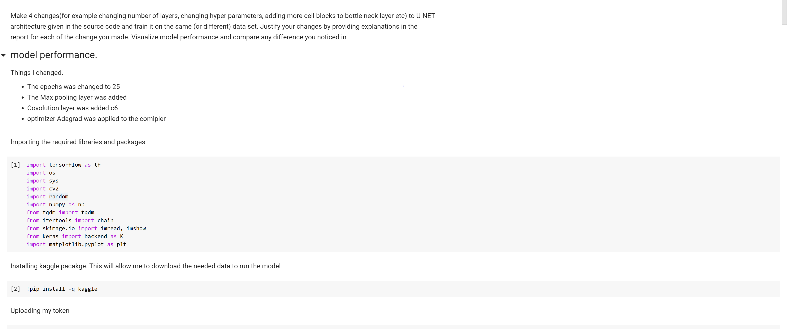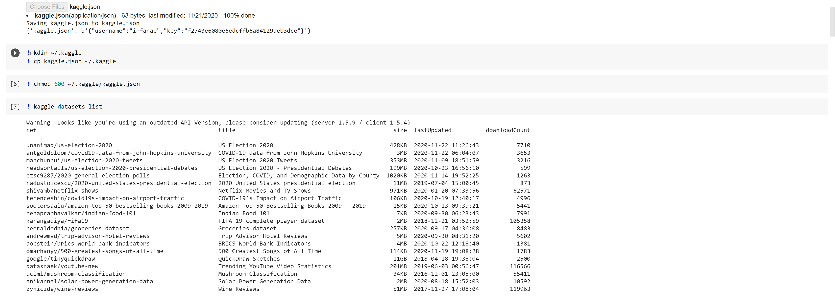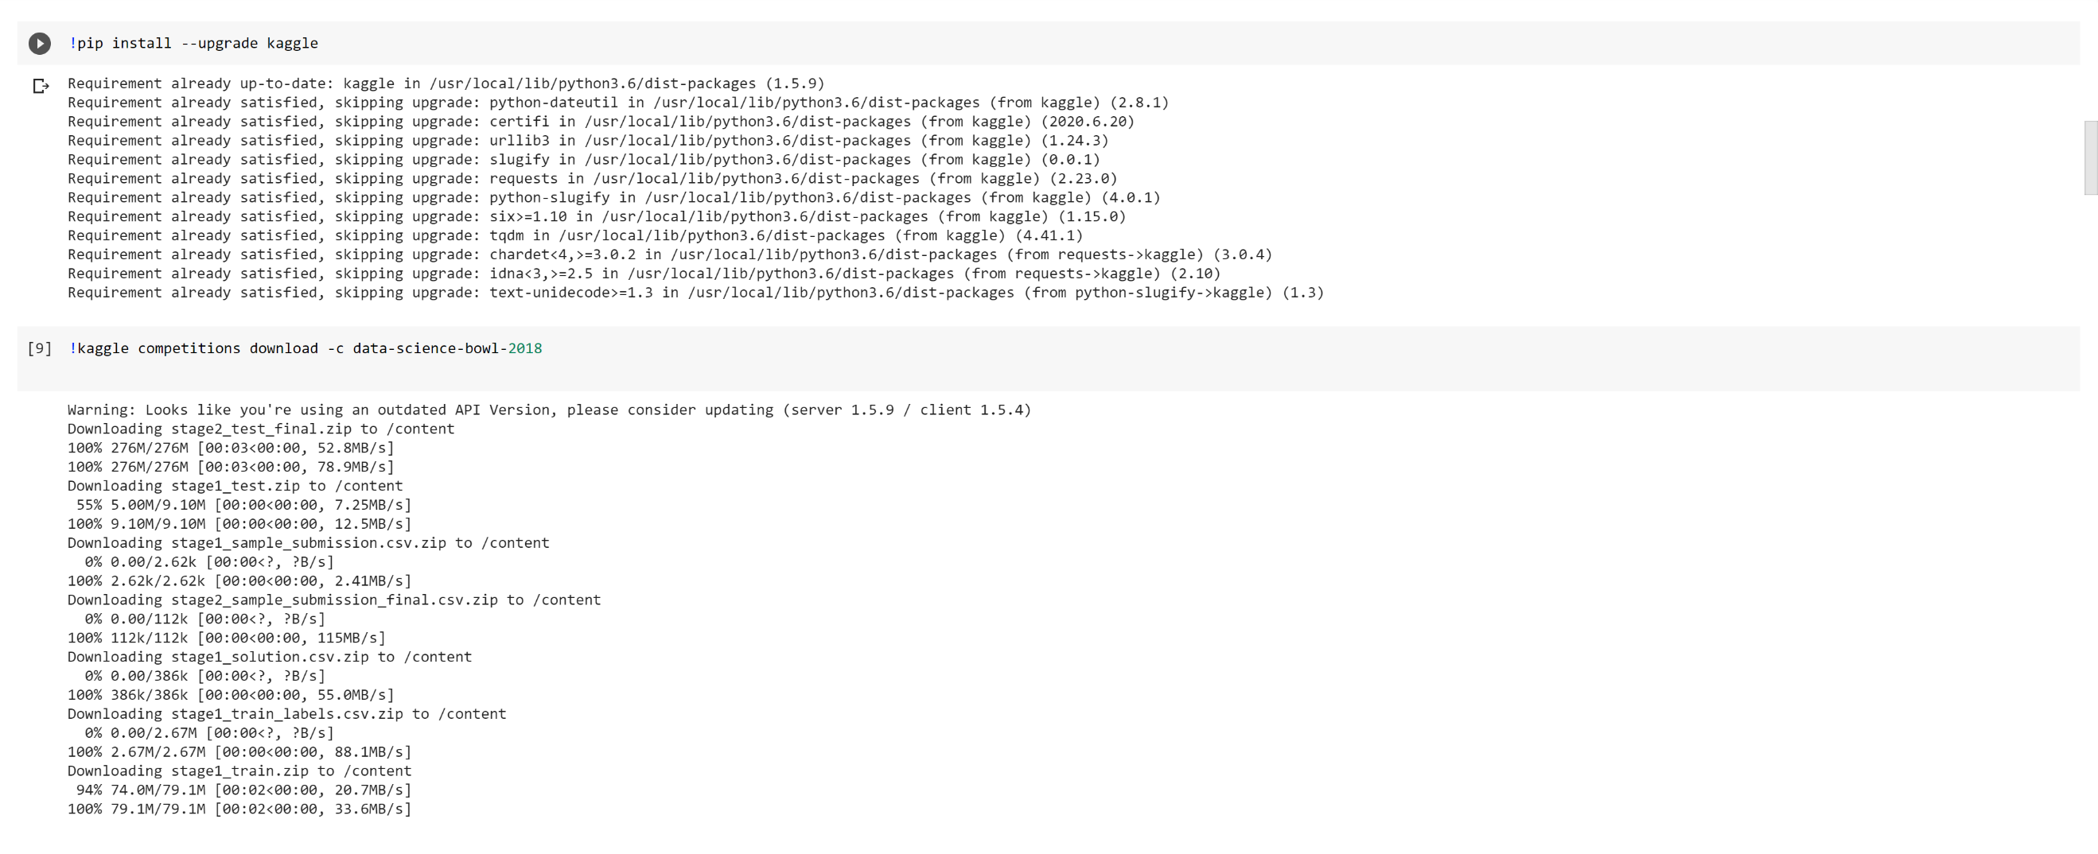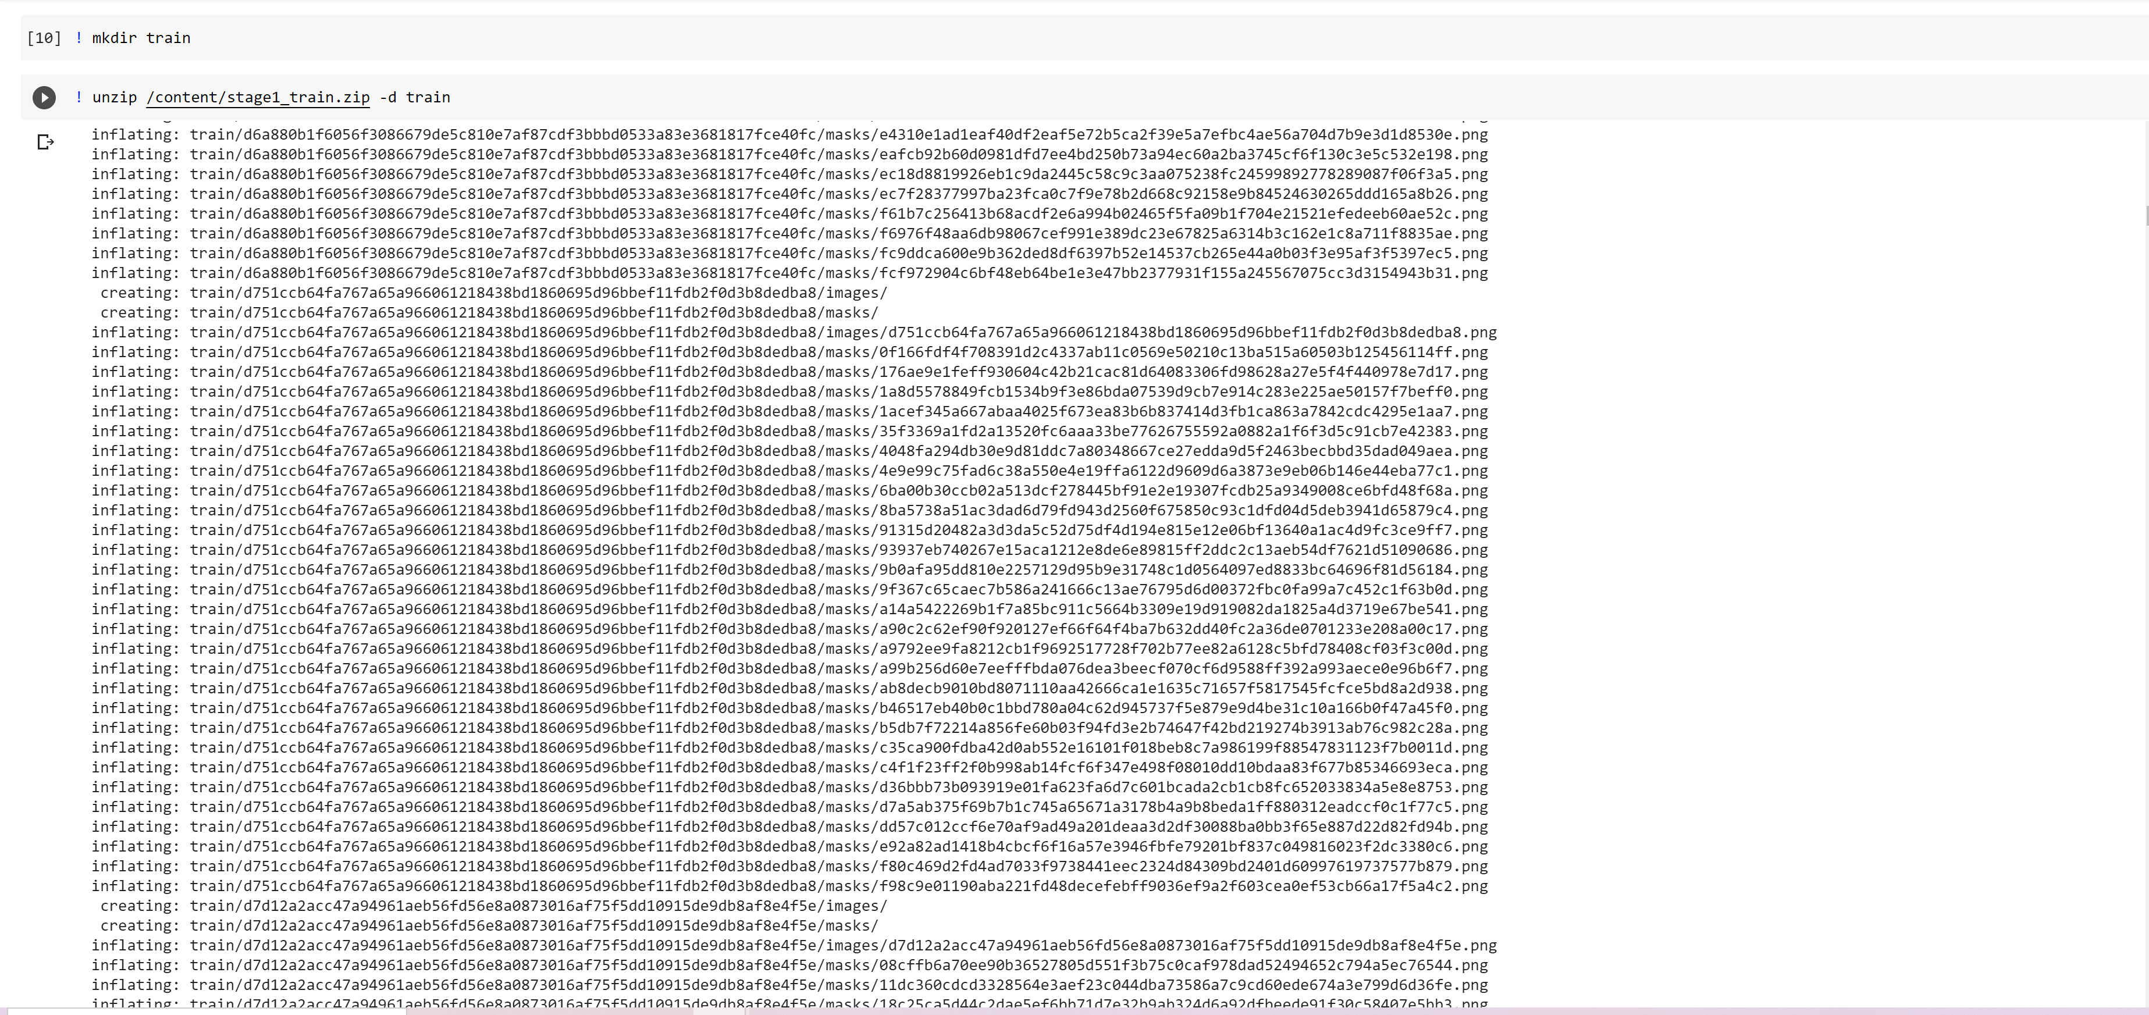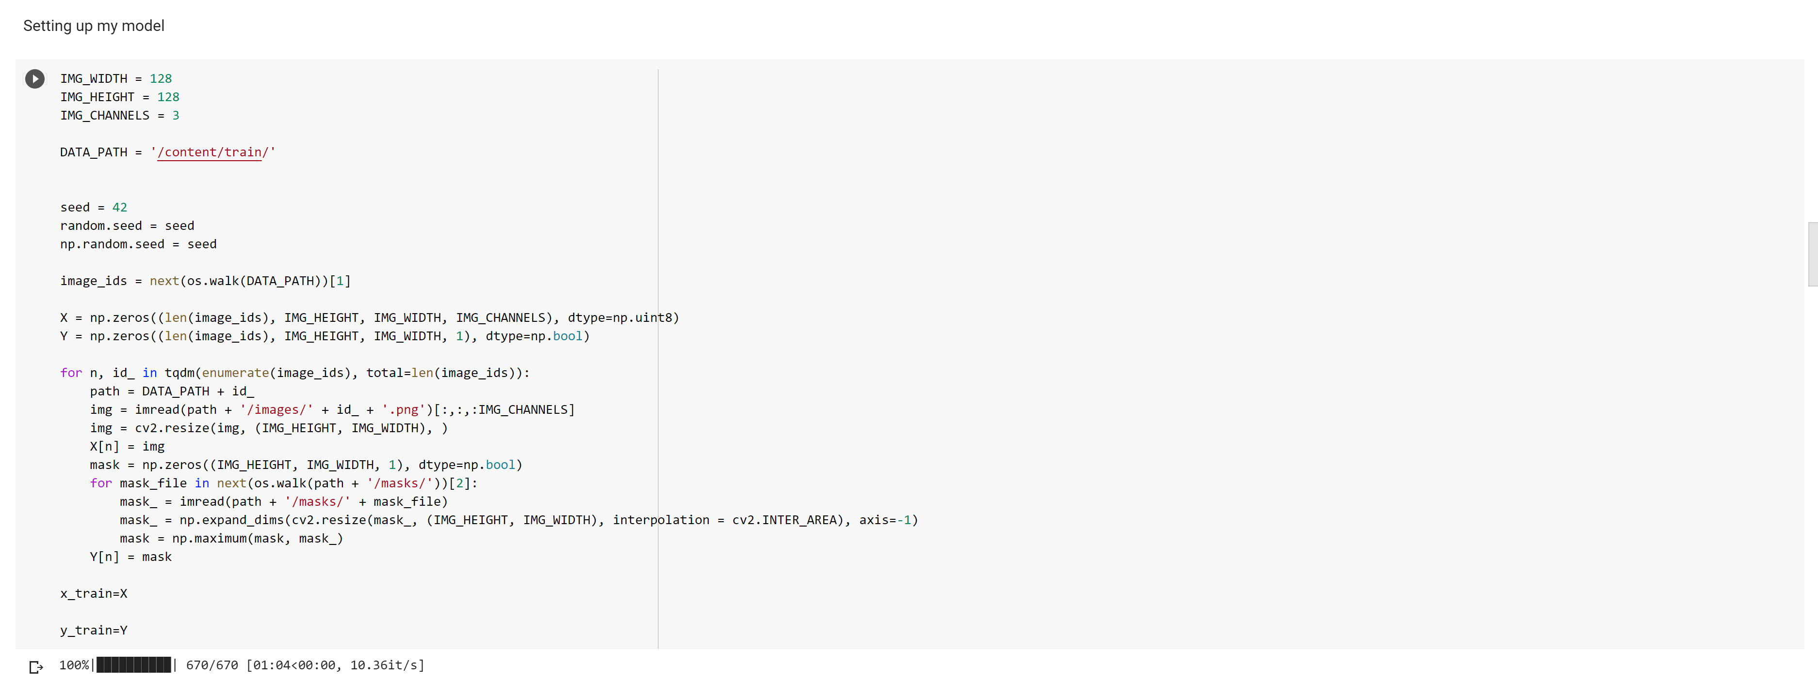 This is the first run without
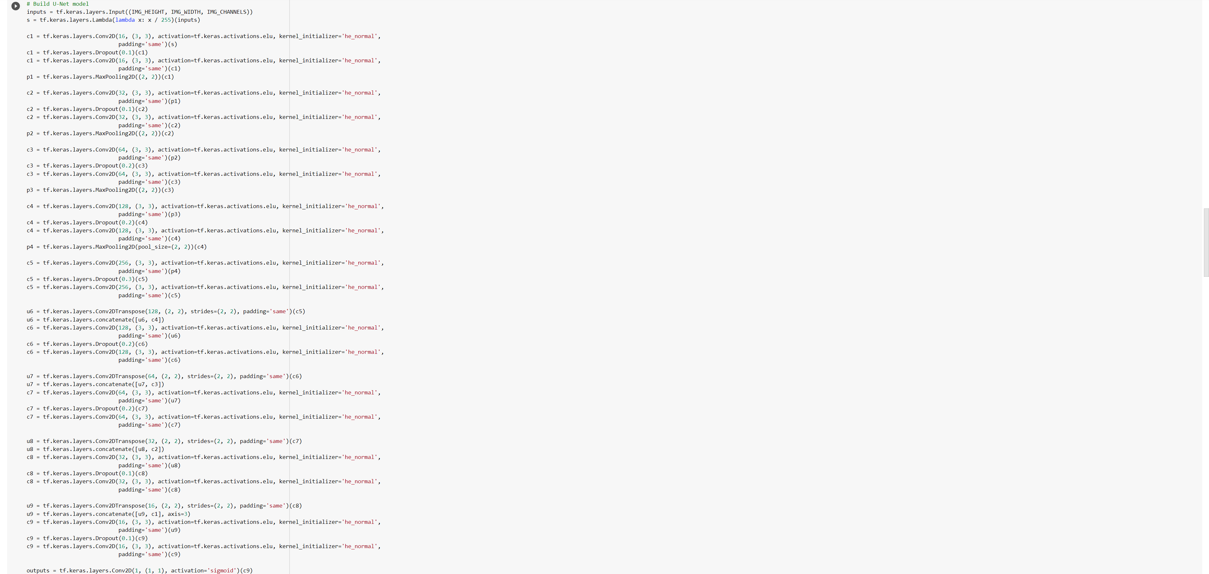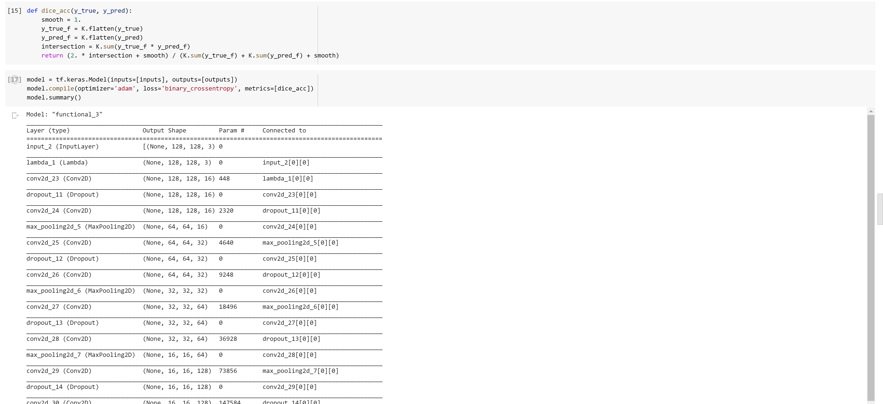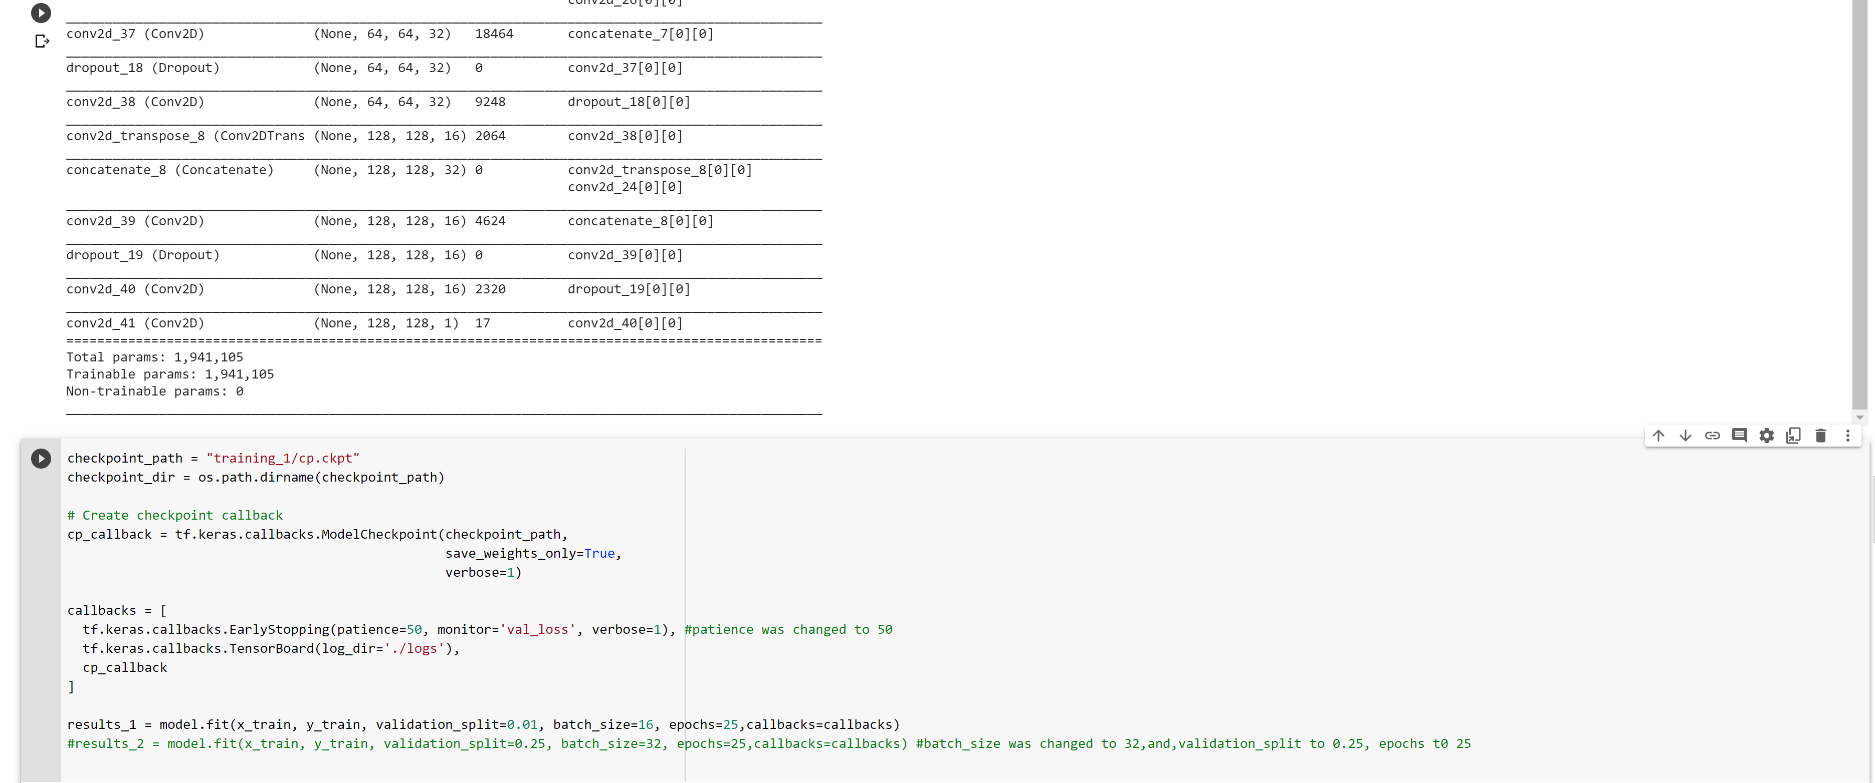

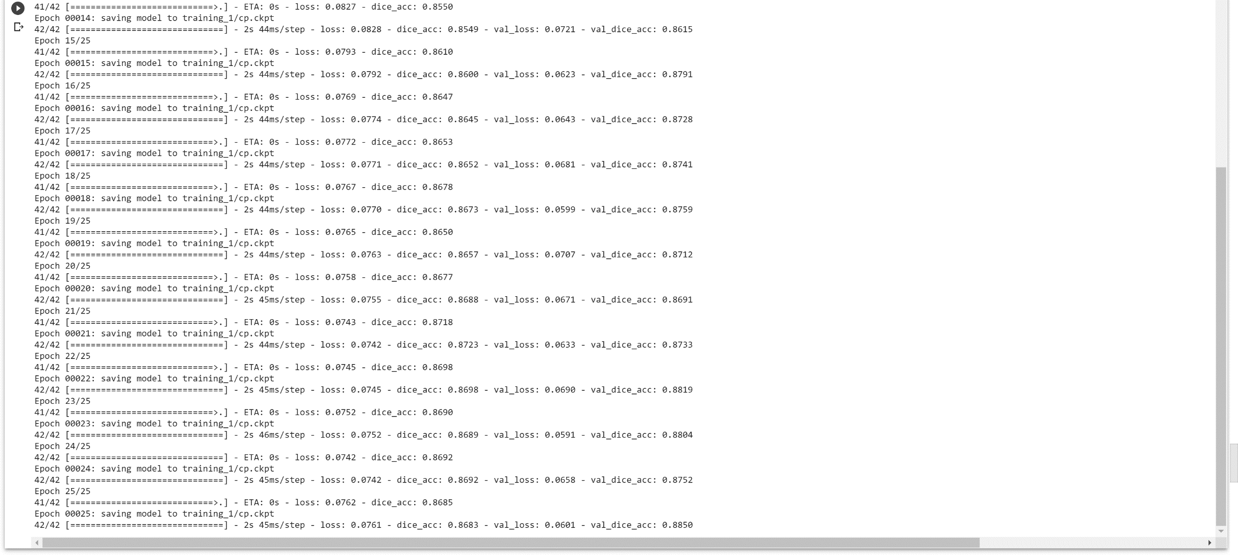

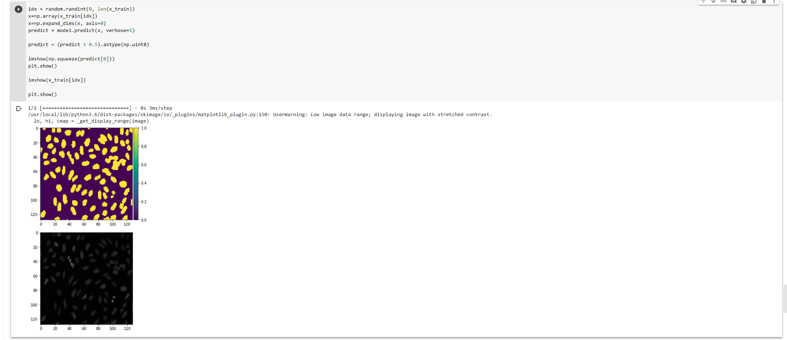
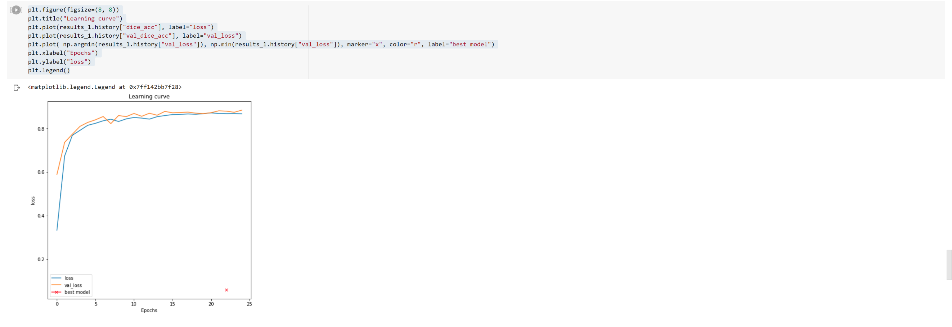

The images below are for result 2 where changes were made, and the results compared using visualization.
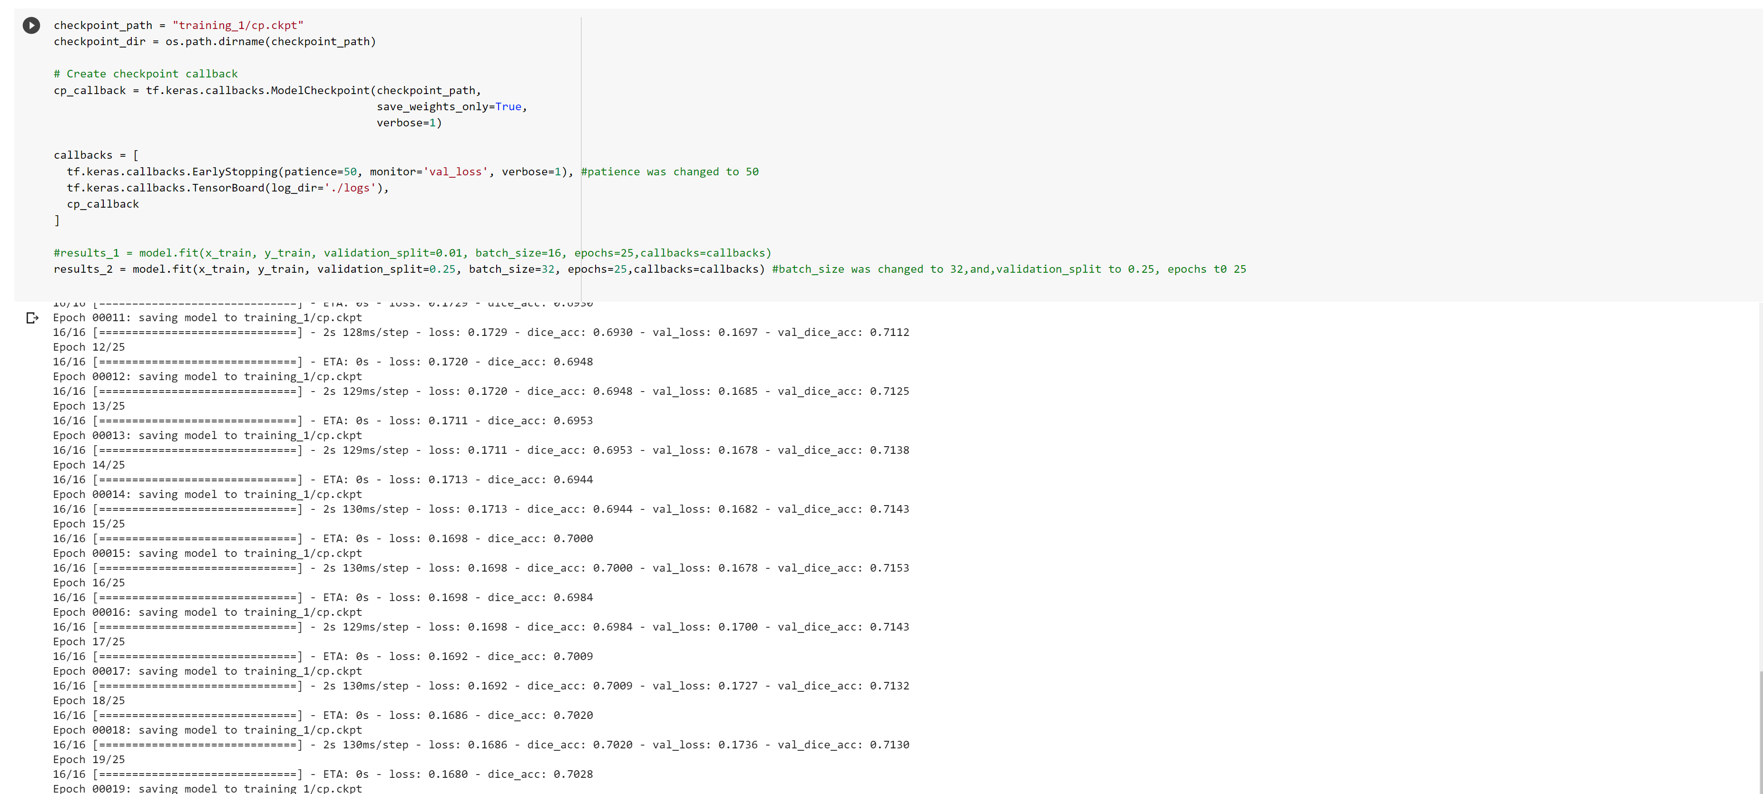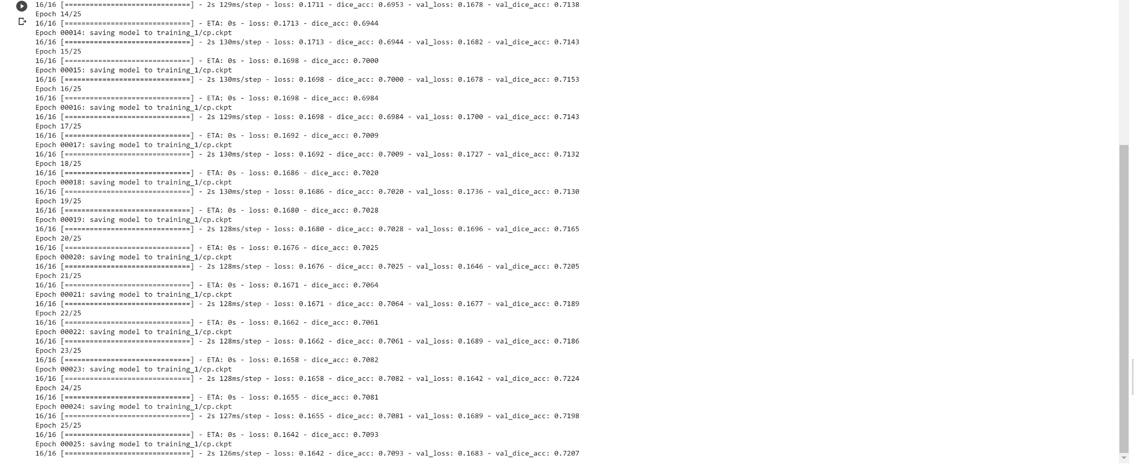

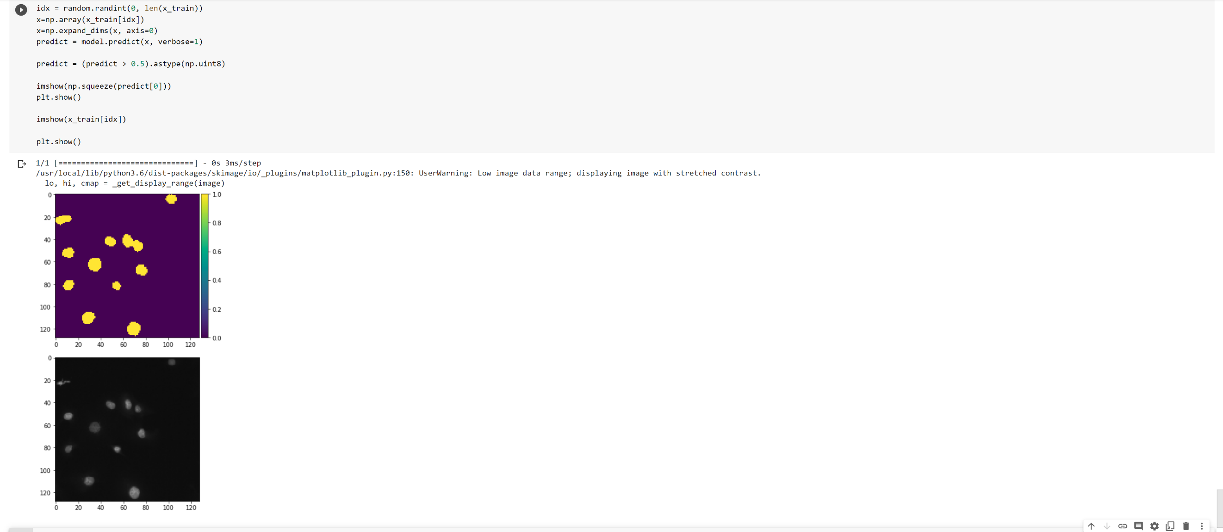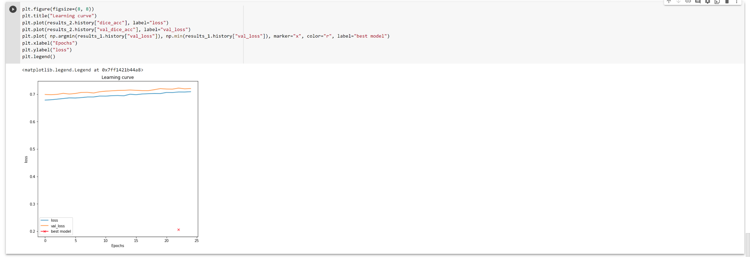
- Output file link if applicable
https://github.com/UMKC-APL-BigDataAnalytics/icp-11-irfancheemaa

- Video link (YouTube or any other publicly available video platform)
https://umkc.hosted.panopto.com/Panopto/Pages/Viewer.aspx?id=f8816e88-b9fb-4150-b3e4-ac7c0158c0fd

- Any inside about the data or the ICP in general

None at the moment.

